Analyzing Client Satisfaction and Service Utilization at the Dempsey Center

Min-Hsin Chang Ziyue Shen

Introduction
The Dempsey Center is a nonprofit organization that provides free support services to individuals and families affected by cancer in Maine. The center has offered a comprehensive range of services including individual counseling, support groups, complementary therapies such as massage and acupuncture, movement and fitness programs, and educational workshops. These services aim to address the physical, emotional, and social challenges that come with a cancer diagnosis.

Each year, the Dempsey Center conducts an annual client survey to assess satisfaction with services, identify areas for improvement, and understand the evolving needs of their client population. This study analyzes four years of survey data from 2022 through 2025, totaling over 1,180 client responses. Our analysis focuses on three primary research questions:

- Has client satisfaction improved over the four-year period?
- Which factors most strongly predict high satisfaction with Dempsey Center services?

By examining satisfaction trends, service utilization patterns, and client demographics, this study aims to provide data-driven insights that can inform the Dempsey Center's strategic planning and resource allocation decisions. Understanding what drives client satisfaction and how different populations engage with services will enable the organization to better serve the cancer-affected community in Maine.

Background
Cancer diagnosis and treatment create significant physical, emotional, and social challenges for patients and their families. Research shows that people with cancer who have social and resource support are less distressed and have a better overall quality of life. Despite this, access to psychosocial support services remains inconsistent, and many patients who could benefit are unaware that such services exist.

The Dempsey Center's model recognizes that cancer affects more than just physical health. Their holistic approach addresses emotional wellbeing through counseling and support groups, physical health through complementary therapies and movement programs, and social connection through community-building activities. Prioritizing psychosocial care can lead to better adherence to treatment plans and a more holistic approach to cancer care, ultimately fostering a supportive environment that recognizes the psychological burdens of cancer.

Research on psychosocial cancer support services indicates that well-being shows significant improvements when concerns are successfully addressed, and that evaluating client satisfaction is essential for understanding service quality and identifying areas for improvement. This analysis builds on the Dempsey Center's commitment to continuous improvement by examining four years of client feedback to provide actionable, data-driven insights.

Methods

3.1 Data Overview and Cleaning
This study draws on four years of annual client survey data from the Dempsey Center, covering 2022 through 2025. The raw datasets contained 270, 298, 293, and 319 responses respectively. Because column positions for equivalent questions shifted across years, each variable's location was manually verified before extraction.

After merging, the combined dataset totaled 1,179 rows. Cleaning involved removing duplicate header rows, standardizing gender labels across years, and dropping rows missing core satisfaction or life improvement values. The final dataset retained 1,047 rows (257 from 2022, 262 from 2023, 252 from 2024, 276 from 2025).

3.2 Analytical Methods
Exploratory Data Analysis. Descriptive visualizations were used to characterize client demographics, satisfaction trends.

Chi-Square Tests. Two tests of independence were conducted to assess associations with high satisfaction ("Very Satisfied" vs. all others): service frequency vs. satisfaction, age vs. satisfaction.

Machine Learning Classification. Four classifiers were trained to predict high satisfaction: Gaussian Naive Bayes, K-Nearest Neighbors (k=3), Decision Tree (max depth=5), and Random Forest (100 estimators, max depth=5). Features were age, gender, service frequency, and cancer status, all label-encoded. Models were evaluated on an 80/20 train-test split and additionally assessed using 5-fold cross-validation.

Results

4.1 Exploratory Data Analysis
Demographics
The client population was predominantly older. The 65–74 age group made up the largest share of respondents, indicating that the Dempsey Center primarily serves an older adult population.
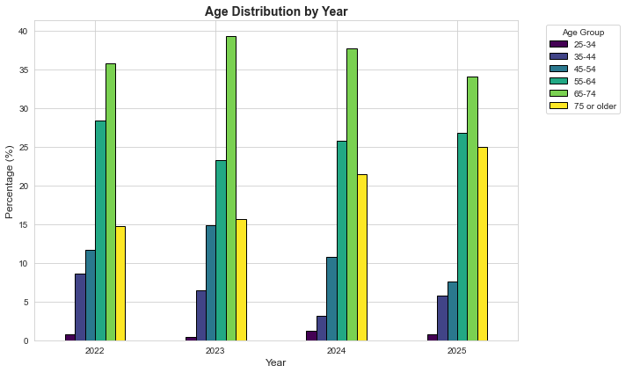
Figure 1. Age distribution of Dempsey Center survey respondents (2022–2025).
Across all four years, approximately 81% of respondents identified as women. This gender composition remained stable over time, suggesting a consistent demographic profile in the client base.
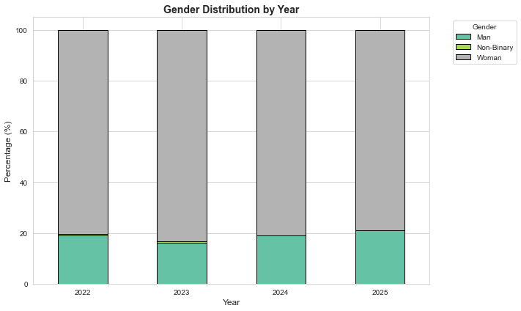
Figure 2. Gender distribution of Dempsey Center survey respondents (2022–2025).
The majority of respondents were cancer survivors or current patients. "I have had cancer" was the most common status, followed by "I currently have cancer". A notable portion of clients were care partners or family members, reflecting the center's broader mission to support those affected by cancer beyond the patients themselves.
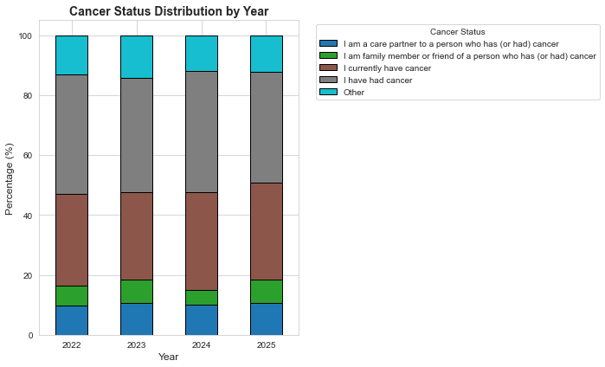
Figure 3. Cancer status distribution across all respondents (2022–2025).

Satisfaction Trends Over Time
Overall satisfaction remained consistently high throughout the study period. The proportion of "Very Satisfied" responses hovered around 76% each year, with no clear upward or downward trend. While the distribution of other response categories (Satisfied, Neither, Unsatisfied, Very Unsatisfied) showed minor fluctuations year to year, the overall picture suggests stable service quality.
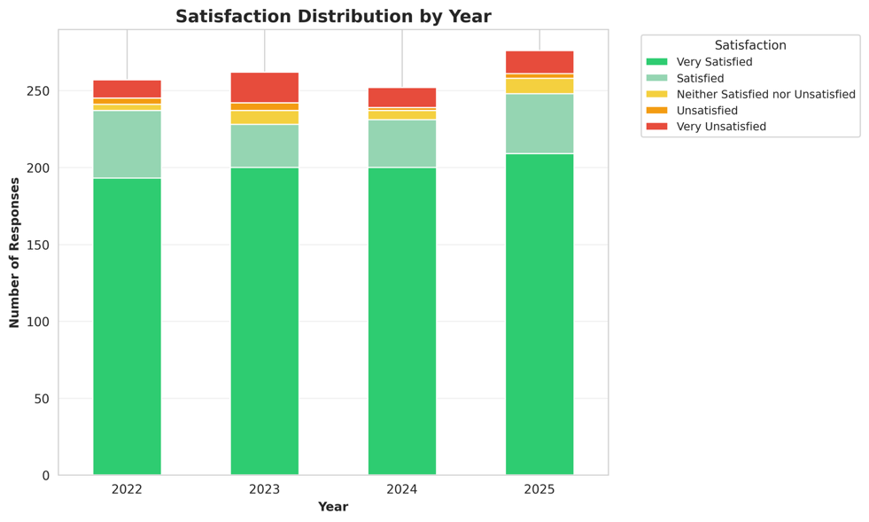
Figure 4. Satisfaction ratings by year (2022–2025).
Between 95% and 97% of respondents each year reported that Dempsey Center services made their life better. This metric was the most consistently positive finding across the entire dataset, with virtually no meaningful variation across years.
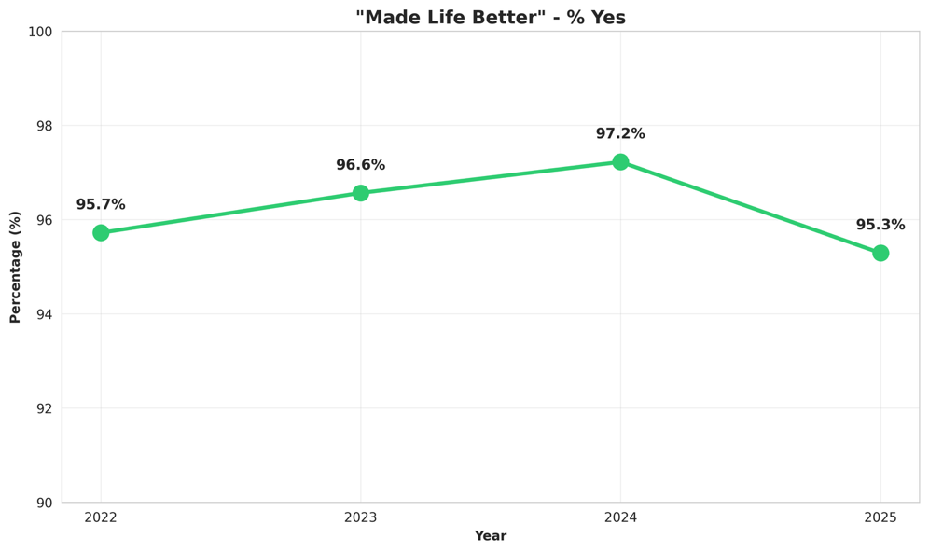
Figure 5. Proportion of respondents who reported services made their life better (2022–2025).
Emotional wellbeing tops the list of benefits, with over 60% of clients reporting reduced distress through the center's support. Nearly half also valued the sense of community and social connection fostered by their programs. Notably, while physical symptom relief ranks lower at 34%, the psychological and social impacts appear to be the center's strongest value drivers.
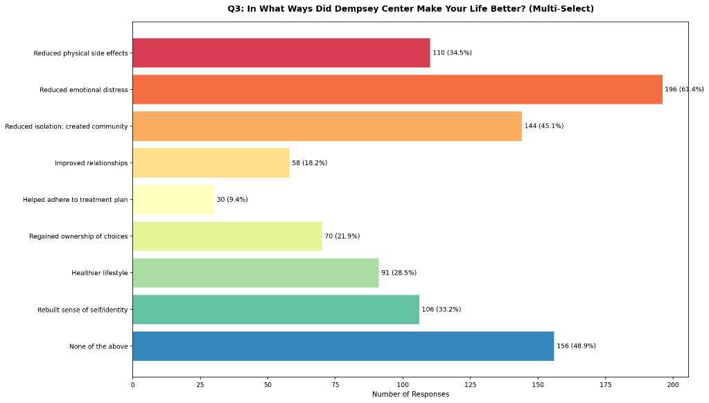
Figure 6. How Clients' Lives Improved(2025)

Service Utilization
The frequency distribution remained broadly consistent year over year, with high-frequency usage (more than 10 times) dominating each year. This pattern suggests that engagement levels have not shifted significantly despite the modest growth in total respondents.
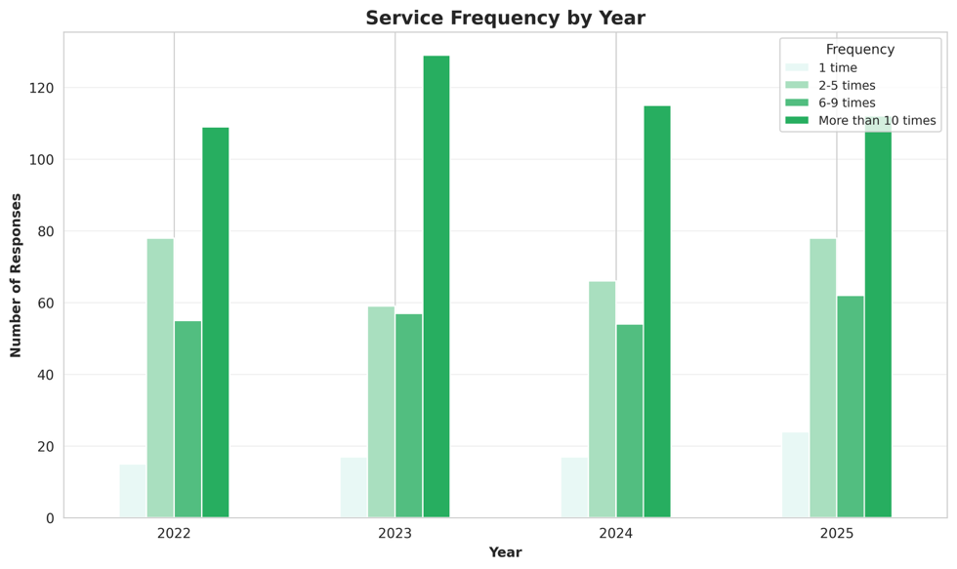
Figure 7. Service frequency distribution broken down by year (2022–2025).
Westbrook (Rock Row) emerges as the most utilized location, drawing over half of all clients. Virtual live services rank a close second at nearly 46%, demonstrating strong demand for remote care options. The data reveals a clear preference for hybrid access, combining in-person convenience with digital flexibility.
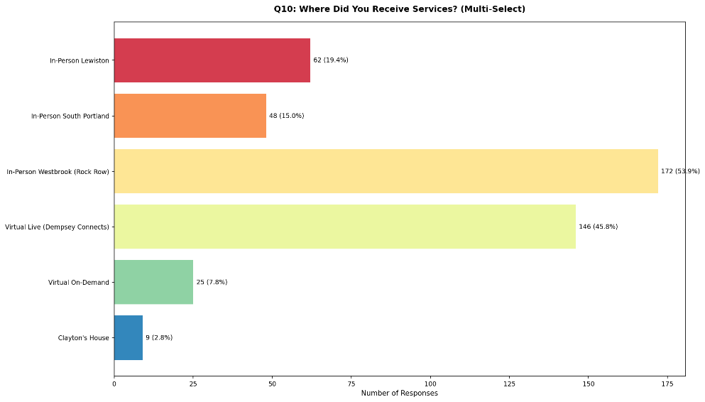
Figure 8. Service Location Preferences(2025)

4.2 Statistical Tests
Two chi-square tests of independence were conducted to assess whether key variables were associated with high satisfaction (defined as reporting "Very Satisfied").

Service frequency showed the strongest association with satisfaction (χ²=66.05, p<0.0001). Clients who used services more frequently were substantially more likely to report high satisfaction — 86% of those who visited more than 10 times reported being very satisfied, compared to only 49% of those who visited just once. This dose-response pattern suggests that repeated engagement with the center's services is closely tied to client satisfaction.
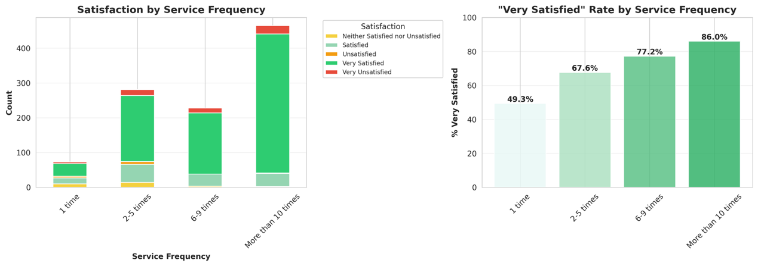
Figure 8. High satisfaction rate by service frequency.
Age was also significantly associated with satisfaction (χ²=13.18, p=0.022). Clients aged 75 or older had the highest satisfaction rate at 84.7%, while the 25–34 group had the lowest at 62.5%. The general trend suggests that older clients tend to report higher satisfaction, though the sample sizes for younger age groups were small.
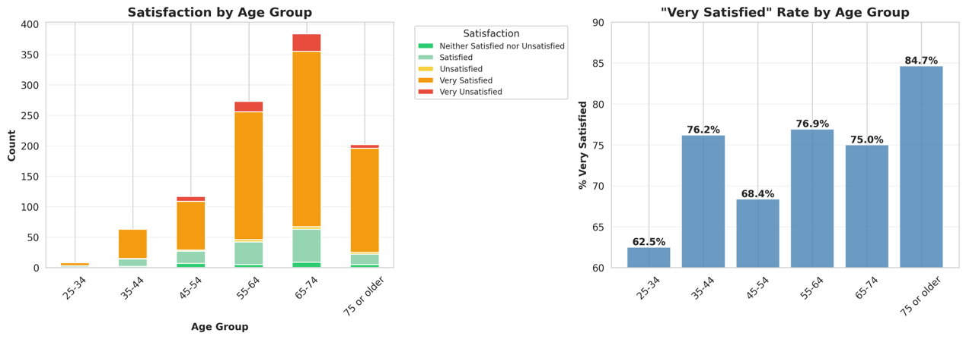
Figure 9. High satisfaction rate by age group.

4.3 Machine Learning Classification
Four classifiers were trained to predict whether a client would report "Very Satisfied," using age, gender, service frequency, and cancer status as features.

Under 5-fold cross-validation, Gaussian Naive Bayes remained the strongest model (76.1% ± 1.4%), suggesting it generalizes well to unseen data. The relatively narrow gap between models indicates that the feature set has moderate but consistent predictive power.

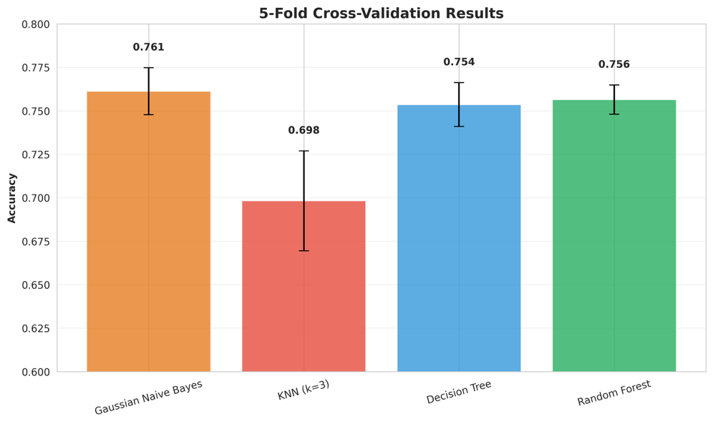
Figure 10. 5-fold cross-validation accuracy for each classifier.
Feature importance analysis identified service frequency as the dominant predictor of satisfaction, with importance scores of 0.446. Age and cancer status were secondary contributors, while gender had the lowest importance across both models. This ranking aligns with the chi-square results and reinforces the central role of service engagement in predicting client satisfaction.
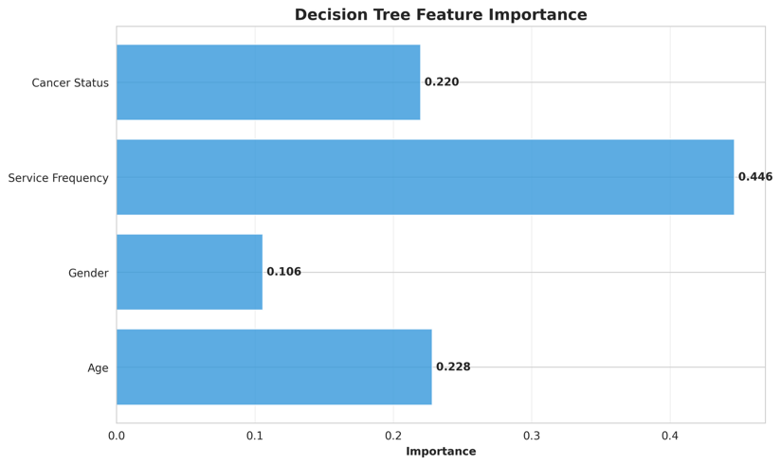
Figure 11. Decision Tree feature importance.

Confusion matrices show strong performance on the majority "Very Satisfied" class but limited recall on minority classes such as "Unsatisfied" and "Very Unsatisfied." This is expected given the class imbalance in the dataset, where over 76% of responses fall in the "Very Satisfied" category.
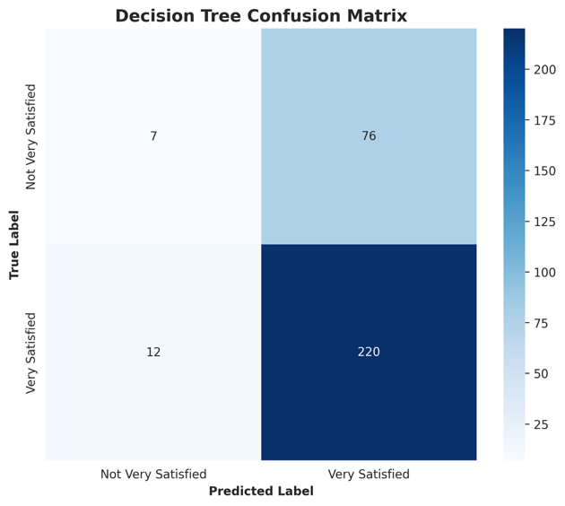
Figure 12. Decision Tree confusion matrix.

Discussion
This study analyzed four years of client survey data from the Dempsey Center to assess satisfaction trends and identify predictors of high satisfaction. Overall satisfaction remained stable at around 76% "Very Satisfied" across 2022–2025, and 95–97% of clients consistently reported that services made their life better — both findings reflect well on the center's service quality over time.

Service frequency was the strongest predictor of satisfaction across all analytical methods. Age showed a secondary but significant effect, with older clients reporting higher satisfaction.

Based on these findings, the Dempsey Center may benefit from strategies that encourage clients to return beyond a first visit — such as follow-up outreach, introductory program series, or reduced-barrier entry points for new clients. Particular attention to the needs of younger and lower-engagement clients could help close the satisfaction gap.

Limitation
Several limitations should be considered when interpreting these findings. First, the survey captures only clients who actively completed the annual questionnaire, introducing selection bias — clients with more negative experiences or lower engagement may be less likely to respond, which could inflate overall satisfaction rates.

Second, the survey instrument changed across the four years studied, with column counts growing from 72 to 105. While core variables were manually verified and extracted consistently, some variables were only available for certain years and could not be included in the longitudinal analysis.

Finally, the class imbalance in the outcome variable (76% "Very Satisfied") constrained the classifiers' ability to predict minority satisfaction levels. Future work could apply resampling techniques such as SMOTE to address this issue.

Future Work
To deepen our understanding of client experiences, future research should adopt a longitudinal approach that tracks individual clients across multiple time points, allowing us to observe how satisfaction and service needs evolve throughout their cancer journey rather than capturing only a single moment in time. Additionally, leveraging natural language processing (NLP) techniques to analyze open-ended feedback would reveal nuanced emotional patterns and specific pain points that structured survey questions might miss, providing richer qualitative insights to complement quantitative metrics.

References

Dempsey Center. (2025). About the Dempsey Center. https://www.dempseycenter.org/about/

American Cancer Society. (2025). Therapy, counseling, and support resources for people with cancer. https://www.cancer.org/cancer/survivorship/coping/understanding-psychosocial-support-services.html

Gao, Y., et al. (2024). Global unmet psychosocial needs in cancer care: Health policy. eClinicalMedicine. https://doi.org/10.1016/j.eclinm.2024.102855

Sautier, L., et al. (2021). Evaluations of psychosocial cancer support services: A scoping review. PLOS ONE. https://doi.org/10.1371/journal.pone.0251126

